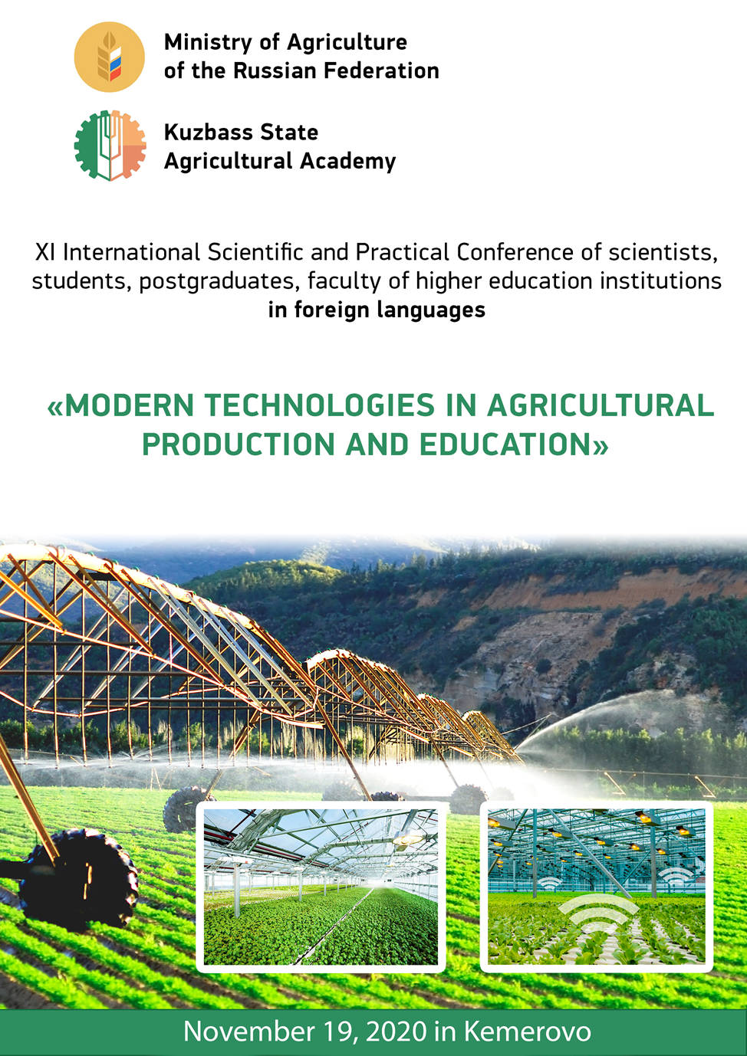

DEAR COLLEAGUES !
Kuzbass State Agricultural Academy invites you to take part in the XI International Scientific and Practical Conference of scientists, students, postgraduates, faculty of higher education institutions in foreign languages "MODERN TECHNOLOGIES IN AGRICULTURAL PRODUCTION AND EDUCATION", which will be held November 19, 2020 in Kemerovo.
Postgraduate students, teachers, scientists, employees of universities, research institutes, agricultural and processing enterprises are invited to participate in the conference.
The conference working languages are English and German.
The conference proceedings will be included in the Russian Science Citation Index (RSCI).
The main purpose of the conference is to use the scientific potential of students, postgraduates, faculty to understand and develop modern technologies in agriculture and education, teaching methods of foreign languages.

CONFERENCE WORKSHOPS:

1. Modern technologies in agriculture in Russia and foreign countries;
2. Rational land use;
3. Problems of ecology and environmental education in a modern university;
4. Innovative technologies in education;
5. Problems of humanitarian and economic sciences.

PARTICIPATION CONDITIONS:

Participants must submit by November 9, 2020:
1) an article in electronic form, taking into account the above design requirements, up to 4 pages in length.
2) the participant's application according to the form.
3) a receipt of payment of the organizational fee.
The Organizing Committee reserves the right to reject materials that do not meet the content or formal requirements.
For publication of materials of the Conference (RSCI) the organizational fee in the amount of 350 rubles is provided. (VAT incl.) for one page of printed text (articles of Doctors of Sciences are published free of charge);
The organization fee is paid only after the review and confirmation of the steering committee about the possibility of publishing the article.

Payment instructions:
FSBEI of Higher Education Kuzbass State Agricultural Academy
650056, Kemerovo, Markovtseva St., 5
TIN 4205035690 RRC 420501001
OKONkh92110 OKPO 26647331
ОКТМО 32701000 BIC 043207001
PSRN 1024240680199 of 12.08.2002. Recipient of FTD for Kemerovo region
(FSBEI of Higher Education Kuzbass State Agricultural Academy separate account 20396X20640)
Transactional account 40501810700002000001 Branch of Kemerovo BCC 00000000000000000130

The materials are sent by e-mail to intermir42@mail.ru in the name of Tatyana Miroshina. If you have any questions, please contact us at the same address or by phone +7(3842) 75- 32-33. You can also fill out an application for participation in the conference at www.ksai.ru on the page "Scientific events".

CONFERENCE PARTICIPATION FORM
The Conference Organizing Committee accepts applications for participation in person and by correspondence. The format of the conference assumes a presentation by the participants in one of the working languages of the conference. The duration of the speech is 5-7 minutes. At the end of the conference it is supposed to issue an electronic collection, which will be placed on the website of the university. The collection will be included in the Russian Scientific Citation Index (RSCI).

ARTICLE LAYOUT REQUIREMENTS

An article in a foreign language of up to 4 pages of A4 typewritten text in the form of a file typed in the Word editor (font Times New Roman, pin 14) at an interval of one and a half. Fields 2,5 cm - from all sides. The paragraph indent is 1.25 cm. At the beginning of the article specify UDC in the upper left corner. Next, specify the title of the article in capital letters in foreign and Russian and its center alignment. Below in one line are the authors' surnames and initials in lowercase letters with degrees and titles, institutions, center alignment. Then in one line of the resume in the Russian language. Next, after two lines, the text of the article in a foreign language in lowercase letters, ordinary font, alignment in width. Tables and figures are allowed in the text not exceeding 3. At the end of the article in one line - the bibliographic list, designed in accordance with generally accepted rules. The text should represent an independent scientific study and contain conclusions on the study.

Example of article design:
УДК
ИСПОЛЬЗОВАНИЕ СОВРЕМЕННЫХ ТЕХНОЛОГИЙ
В СЕЛЬСКОМ ХОЗЯЙСТВЕ

USE OF MODERN TECHNOLOGIES IN AGRICULTURE

Иванов А.А., к.т.н., доцент, Кузбасская государственная сельскохозяйственная академия, A.A. Ivanov, Ph.D., Associate Professor, Kuzbass state agricultural Academy

Abstract (in Russian)

Тext …………………………………………………………

List of references: (in Russian)
1.
2.
(in alphabetic order ). A reference in the text to the cited works is drawn up as follows: [1: 25].

In electronic form, each article should be sent as a separate file. In the name of the file, please specify the surname and initials of the author (example: Ivanov AA_ article).

Example of application form for participation in the conference
Last, first and middle names ____________________________________________
Place of employment/studying _________________________________________________
Academic rank ______________________________________
Academic degree ______________________________________________________
Article title______________________________________________________
Last, first and middle names of supervisor (for students and graduate students) _________
Post address: _________________________________________________
Telephone:______________________________________________
Е-mail: __________________________________________________________
Form of participation (with report/ without report)

The application, sent by e-mail, is executed as follows: Ivanov А. А._application.

The author's style is preserved in the conference materials. The Organizing Committee of the conference on the results of examination of materials reserves the right to decide on the publication of the report in the conference proceedings.
If you have not confirmed receipt of the article and application, please send them again from another computer.

