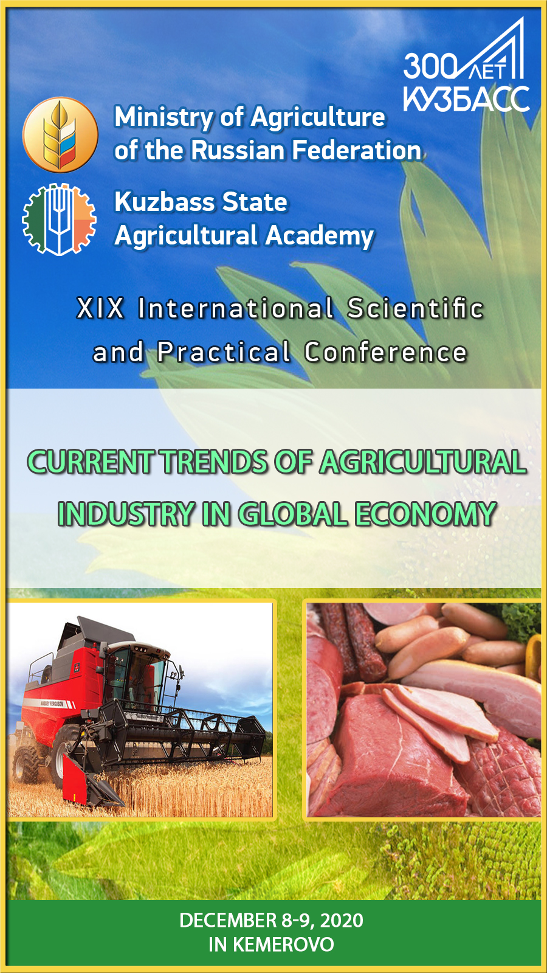
DEAR COLLEAGUES !
Kuzbass State Agricultural Academy invites you to take part in the work of the IV International Scientific and Practical Conference "Current trends of agricultural industry in global economy", which will be held within the framework of the implementation of the program of REC "Kuzbass" December 8-9, 2020 in Kemerovo.
Postgraduate students, teachers, scientists, employees of universities, research institutes, agricultural and processing enterprises are invited to participate in the conference.
The conference working languages are Russian and English.
The conference proceedings will be included in the Russian Science Citation Index (RSCI).
Selected articles from the conference proceedings will be published in a collection indexed in the Web of Science database in 2021.

STEERING COMMITTEE:
Izhmulkina Ekaterina Alexandrovna - Chairman, Rector ad interim, Vice-Rector for R&D of Kuzbass State Agricultural Academy; Candidate of Economic Sciences, Associate Professor;
Konstantinova Olga Borisovna - Deputy Chairman, Head of the Scientific Department of the Kuzbass State Agricultural Academy; Candidate of Agricultural Sciences;
Egushova Elena Anatolyevna - Associate Professor of the Department of Agrobiotechnology of Kuzbass State Agricultural Academy; Candidate of Technical Sciences;
Khromova Tatiana Yuryevna - Associate Professor of the Department of Humanitarian Disciplines of the Kuzbass State Agricultural Academy; Candidate of Historical Sciences;
Bondareva Galina Sergeyevna - Associate Professor of the Department of Management and Agribusiness of Kuzbass State Agricultural Academy; Candidate of Economic Sciences;
Sankina Olga Vladimirovna - Associate Professor of the Department of Agricultural Engineering of Kuzbass State Agricultural Academy; Candidate of Engineering Sciences;
Chalova Natalia Anatolyevna - Head of the Department of Breeding and Genetics in Animal Husbandry of Kuzbass State Agricultural Academy; Candidate of Agricultural Sciences;
Pazin Maksim Аnatolyevich – Associate Professor of the Department of Agronomy, Selection and Seed Breeding of Kuzbass State Agricultural Academy; Candidate of Agricultural Sciences;
Yakovchenko Marina Alexandrovna - Associate Professor of the Department of mathematics, physics and information technology of Kuzbass State Agricultural Academy; Candidate of Chemical Sciences;
Vityaz Svetlana Nikolayevna – Head of the Department of Landscape Architecture of Kuzbass State Agricultural Academy; Candidate of Biological Sciences;
Marinov Nikolay Andreyevich - Head of Innovation Technologies Department of Kuzbass State Agricultural Academy;
Berezina Anna Sergeyevna - Head of the Centre for Digital Education and Scientific Educational Resources of Kuzbass State Agricultural Academy;
Machnova Svetlana Anatolyevna - Specialist of the Scientific Department of Kuzbass State Agricultural Academy.

IMPORTANT INFORMATION:

Location: FSBEI of Higher Education Kuzbass State Agricultural Academy, 650056, Kemerovo region, Kemerovo, Markovtseva St., 5
Telephone in case of query: +7 923 507 12 89
E-mail address: library82@mail.ru
Contact persons: Konstantinova Olga Borisovna, Machnova Svetlana Аnatolyevna.

INFORMATION FOR CONFERENCE PARTICIPANTS WITH INDEXATION OF MATERIALS IN THE RUSSIAN SCIENCE CITATION INDEX
(RSCI):

Conference Workshops
1. Development of feed additives and feeding of farm animals and birds.
2. Robotics and mechanization in AIC.
3. Genetics and selection in animal husbandry.
4. Innovative technologies of agricultural products processing.
5. Functional nutrition: relevance and technologies.
6. Bioremediation, ecology and environmental management.
7. Aquaculture: status and development paths.
8. Modern problems of agronomy and ways of their solution.
9. Veterinary medicine and zootechnics.
10. Economic instruments of AIC development.

Participation conditions
Participants must submit to the Steering Committee by November 20, 2020:
1) Article in electronic form, taking into account the above design requirements, from 4 to 10 pages;
2) An application of the Participant according to the form;
3) The Steering Committee reserves the right to reject materials that do not meet the content or formal requirements.
For publication of materials of the Conference (RSCI) the organizational fee in the amount of 150 rubles is provided. (VAT incl.) for one page of printed text (for postgraduate students free of charge).

The organization fee is paid only after the review and confirmation of the steering committee about the possibility of publishing the article.
Payment instructions:
FSBEI of Higher Education Kuzbass State Agricultural Academy
650056, Kemerovo, Markovtseva St., 5
TIN 4205035690 RRC 420501001
OKONkh92110 OKPO 26647331
ОКТМО 32701000 BIC 043207001
PSRN 1024240680199 of 12.08.2002. Recipient of FTD for Kemerovo region
(FSBEI of Higher Education Kuzbass State Agricultural Academy separate account 20396X20640)
Transactional account 40501810700002000001 Branch of Kemerovo BCC 00000000000000000130

Reference: registration fee.

INFORMATION FOR CONFERENCE PARTICIPANTS WITH INDEXATION OF MATERIALS IN WEB OF SCIENCE

Conference Workshops
1. Development of feed additives and feeding of farm animals and birds.
2. Robotics and mechanization in AIC.
3. Genetics and selection in animal husbandry.
4. Innovative technologies of agricultural products processing.
5. Functional nutrition: relevance and technologies.
6. Bioremediation, ecology and environmental management.
7. Aquaculture: status and development paths.
8. Modern problems of agronomy and ways of their solution.
9. Veterinary medicine and zootechnics.
10. Economic instruments of AIC development.

Participation conditions
Participants must submit to the Steering Committee by November 20, 2020:
1) Article in electronic form, taking into account the above design requirements, from 4 to 10 pages;
2) An application of the Participant according to the form;
3) The Steering Committee reserves the right to reject materials that do not meet the content or formal requirements.
For publication in a journal indexed in the Web of Science database, a payment of 20,000 rubles is provided. (VAT incl.) for one article. The price includes translation of the article into English. The contract and bank details for payment will be sent to the authors of accepted articles by e-mail together with the confirmation of acceptance of the article.

The requirements for the articles design are presented at http://event.ksai.ru on the tab of this conference.

List of references

APPLICATION FORM
Last, first and middle names
Place of employment/studying, academic rank
Academic degree
Conference participation with indextation of materials in journals in:
RSCI
Web of Science
Form of participation
full-time  remote  extra-mural | with report  without report
Telephone
E-mail
Article Title:
Conference Workshop:
I hereby request you to book a place at the hotel
from______________to______________2020 .
Room categories (single, double)

