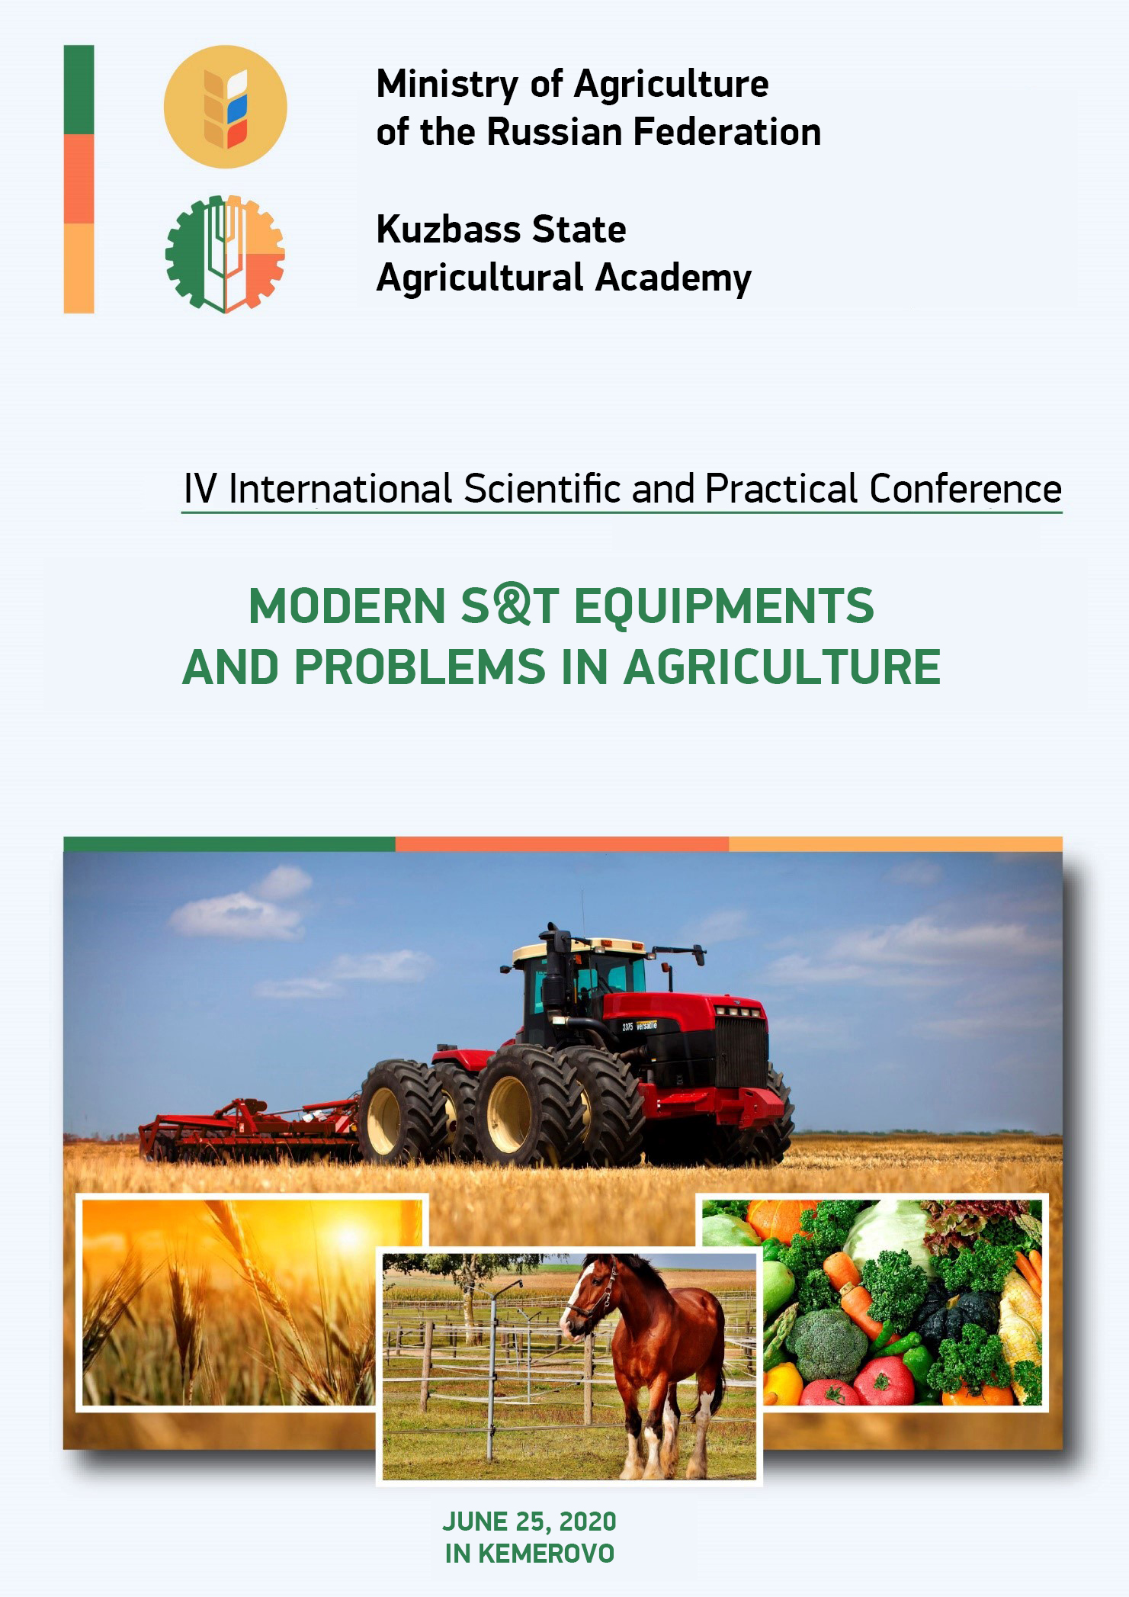

**DEAR COLLEAGUES !**

Kuzbass State Agricultural Academy invites you to take part in the work of the IV International Scientific and Practical Conference "Modern S&T equipments and problems in Agriculture", which will be held within the framework of the implementation of the program of REC "Kuzbass" **June 25, 2020 in Kemerovo.**

Postgraduate students, teachers, scientists, employees of universities, research institutes, agricultural and processing enterprises are invited to participate in the conference.

The conference working languages are Russian and English.

The conference proceedings will be included in the Russian Science Citation Index (RSCI).

Selected articles from the conference proceedings will be published in a collection indexed in the Web of Science database in 2020.

**CONFERENCE WORKSHOPS :**

1. Development of feed additives and feeding of farm animals and birds.

2. Robotics and mechanization in AIC.

3. Genetics and selection in animal husbandry.

4. Innovative technologies of agricultural products processing.

5. Functional nutrition: relevance and technologies.

6. Bioremediation, ecology and environmental management.

7. Aquaculture: status and development paths.

8. Modern problems of agronomy and ways of their solution.

9. Veterinary medicine and zootechnics.

10. Socio-economic tools of AIC.

**STEERING COMMITTEE:**

**Izhmulkina Ekaterina Aleksandrovna -** Chairman, Rector ad interim, Vice-Rector for R&D of Kuzbass State Agricultural Academy; Candidate of Economic Sciences, Associate Professor;

**Konstantinova Olga Borisovna -** Deputy Chairman, Head of the Scientific Department of the Kuzbass State Agricultural Academy; Candidate of Agricultural Sciences;

**Egushova Elena Anatolyevna -** Associate Professor of the Department of Agrobiotechnology of Kuzbass State Agricultural Academy; Candidate of Technical Sciences;

**Khromova Tatiana Yuryevna -** Associate Professor of the Department of Humanitarian Disciplines of the Kuzbass State Agricultural Academy; Candidate of Historical Sciences;

**Bondareva Galina Sergeyevna -** Associate Professor of the Department of Management and Agribusiness of Kuzbass State Agricultural Academy; Candidate of Economic Sciences;

**Sankina Olga Vladimirovna -** Associate Professor of the Department of Agricultural Engineering of Kuzbass State Agricultural Academy; Candidate of Engineering Sciences;

**Chalova Natalia Anatolyevna -** Head of the Department of Breeding and Genetics in Animal Husbandry of Kuzbass State Agricultural Academy; Candidate of Agricultural Sciences;

**Pazin Maksim Аnatolyevich** – Associate Professor of the Department of Agronomy, Selection and Seed Breeding of Kuzbass State Agricultural Academy; Candidate of Agricultural Sciences;

**Yakovchenko Marina Alexandrovna -** Associate Professor of the Department of Landscape Architecture of Kuzbass State Agricultural Academy; Candidate of Chemical Sciences;

**Vityaz Svetlana Nikolayevna -** Head of the Department of Landscape Architecture of Kuzbass State Agricultural Academy; Candidate of Biological Sciences;

**Marinov Nikolay Andreyevich -** Head of Innovation Technologies Department of Kuzbass State Agricultural Academy;

**Berezina Anna Sergeyevna -** Head of the Centre for Digital Education and Scientific Educational Resources of Kuzbass State Agricultural Academy;

**Machnova Svetlana Anatolyevna -** Specialist of the Scientific Department of Kuzbass State Agricultural Academy.

**PARTICIPATION CONDITIONS:**

Participants must submit to the Steering Committee by **April 20, 2020**:

1) Article in electronic form, taking into account the above design requirements, from 4 to 10 pages;

2) An application of the Participant according to the form;

3) The Steering Committee reserves the right to reject materials that do not meet the content or formal requirements.

For publication of materials of the Conference (RSCI) the organizational fee in the amount of 150 rubles is provided. (VAT incl.) for one page of printed text (for postgraduate students free of charge).

The organization fee is paid only after the review and confirmation of the steering committee about the possibility of publishing the article.

Payment instructions:

FSBEI of Higher Education Kuzbass State Agricultural Academy

650056, Kemerovo, Markovtseva St., 5

TIN 4205035690 RRC 420501001

OKONkh92110 OKPO 26647331

ОКТМО 32701000 BIC 043207001

PSRN 1024240680199 of 12.08.2002. Recipient of FTD for Kemerovo region

(FSBEI of Higher Education Kuzbass State Agricultural Academy separate account 20396X20640)

Transactional account 40501810700002000001 Branch of Kemerovo BCC 00000000000000000130

Reference: registration fee.

Materials should be sent to e-mail library82@mail.ru

**ARTICLE LAYOUT REQUIREMENTS**

**The article should contain:** UDC, title of the article in Russian and English, name of the author(s), position, title, organization name, annotation not exceeding 500 characters, keywords in Russian and English.

**The volume of publication is up to 10 pages.** Fields - 2.0 cm on each side, font - Times New Roman, pin 14, line spacing - single; paragraph indent - 1.25 cm; references to literature in square brackets. If there are references, the list of literature is obligatory.

The presence of an abstract and keywords (**in Russian and English**) is mandatory.

**UDC** in the upper left corner, **the title of the article** should be written in capital letters, not deviating from the upper margin, without transfers. **Next line** - last, first and middle names of the author, academic degree, academic rank, position, place of work, country, city, e-mail address. Alignment - in the center.

Next, annotation and keywords - width alignment.

**The text of the article** should be prepared in Microsoft Word editor in .docx or .rtf format. **Formulas** included in the main text should be fully typed in Microsoft Equation Formula Editor with center alignment and skipped line at the top and bottom (formula number is aligned in right field).

Articles that have scientific novelty and approved by the organizing committee will be accepted for publication. **The originality of the article should be at least 70%.**

The editorial board reserves the right to reject materials that do not correspond to the subject matter of the conference or to the design requirements. Spelling and punctuation are preserved by authors.

**All articles of the authors who took part in the conference will be indexed in the system of Russian Scienсе Citation Index (RSCI).**

As a result of the conference, an electronic collection of conference materials will be published with ISBN, UDC and BBC codes assignment, its placement on the conference website and distribution of the disc to libraries, with registration in the Russian Book Chamber.

The materials and results of the IV National Scientific-Practical Conference with international participation "Actual scientific and technical means and agricultural problems" will be available at <http://event.ksai.ru> on the tab of this conference.

**Example of article design**

УДК 615.322

**ОПРЕДЕЛЕНИЕ ОБЩЕЙ ТОКСИЧНОСТИ ФАРМСУБСТАНЦИЙ НА ОСНОВЕ ЭКСТРАКТОВ ЛЕКАРСТВЕННЫХ РАСТЕНИЙ**

Е.В. Ульрих, доктор техн. наук, профессор, О.В. Смоловская, канд. биол. наук, доцент

ФГБОУ ВО Кузбасская ГСХА, Россия, г. Кемерово

E-mail: [elenn.ulrich@mail.ru](mailto:elenn.ulrich@mail.ru)

Determination of general toxicity of pharms substances based on extracts of medicinal plants

E.V. Ulrikh, doctor of technical sciences, professor,

O.V. Smolovskaya, candidate of biological sciences, assistant professor

of Kuzbass State agricultural Academy, Russia, Kemerovo city

**Аннотация.** Результаты, описанные в работе, позволяют объективно оценить общую токсичностиь для живых организмов опытных партий фармсубстанций на основе экстрактов лекарственных растений. Исследовались 12 опытных партий фармсубстанций на основе экстрактов лекарственных растений (из 12 лекарственных растений). Концентрации исследуемого водного раствора фармсубстанций составляла 5%. Выживаемость рачков-цериодафний в контроле составляла 93%.

**Abctract.**The results described in the paper allow an objective assessment of the overall toxicity for living organisms of experimental batches of pharmaceutical substances based on extracts of medicinal plants. We studied 12 experimental batches of pharmaceutical substances based on extracts of medicinal plants (from 12 medicinal plants). The concentration of the investigated aqueous solution of pharmaceutical substances was 5%. The survival rate of the cerodaphnia crustaceans in the control was 93%.

***Ключевые слова:*** *общая токсичность, фармсубстанции, лекарственные растения, рачки, экстракты.*

***Key words:*** *general toxicity, pharmaceutical substances, medicinal plants, crustaceans, extracts.*

Article text

**List of references**

|  |  |
| --- | --- |
| **APPLICATION FORM** | |
| **Last, first and middle names** | |
| **Place of employment/studying, academic rank** | |
| **Academic degree** | |
| **Form of participation** | |
| **full-time**  **remote**  **extra-mural** | **with report**  **without report** |
| **Telephone** | |
| **E-mail** | |
| **Article Title:** | |
| **Conference Workshop:** | |
| **I hereby request you to book a place at the hotel**  **from______________to______________2020.**  Room categories (single, double) | |

**INFORMATION FOR CONFERENCE PARTICIPANTS WITH INDEXATION OF MATERIALS IN WEB OF SCIENCE**

**Conference Workshops**

1. Development of feed additives and feeding of farm animals and birds.

2. Robotics and mechanization in AIC.

3. Genetics and selection in animal husbandry.

4. Innovative technologies of agricultural products processing.

5. Functional nutrition: relevance and technologies.

6. Bioremediation, ecology and environmental management.

7. Aquaculture: status and development paths.

8. Modern problems of agronomy and ways of their solution.

9. Veterinary medicine and zootechnics.

10. Socio-economic tools of AIC.

**Participation conditions**

Participants must submit to the Steering Committee by **April 20, 2020**:

1) Article in electronic form, taking into account the above design requirements, from 4 to 10 pages;

2) An application of the Participant according to the form;

3) The Steering Committee reserves the right to reject materials that do not meet the content or formal requirements.

For publication in a journal indexed in the Web of Science database, a payment of **20,000 rubles** is provided. (VAT incl.) for one article. **The price includes translation of the article into English. The contract and bank details for payment will be sent to the authors of accepted articles by e-mail together with the confirmation of acceptance of the article.**

***The requirements for the articles design are presented at*** <http://event.ksai.ru>  ***on the tab of this conference.***

**IMPORTANT INFORMATION:**

**Location:** FSBEI of Higher Education Kuzbass State Agricultural Academy, 650056, Kemerovo region, Kemerovo, Markovtseva St., 5

**Telephone in case of query:** +7 923 507 12 89

**E-mail address:** [library82@mail.ru](mailto:library82@mail.ru)

**Contact persons:** Konstantinova Olga Borisovna, Machnova Svetlana Аnatolyevna.